**Progress Monitoring**

Written Report

**Team 2**

Team Member:

Bhavsar, Dhruvit Vibhakar

Koshti, Khushboo

Lamichhane, Nishan

Liu, Ziyan

Virk, Ranvir

COMP231(Sec.007)

November 19, 2023

Professor : llir Dema

Centennial College

**Money Analysis - Sprint Planner**

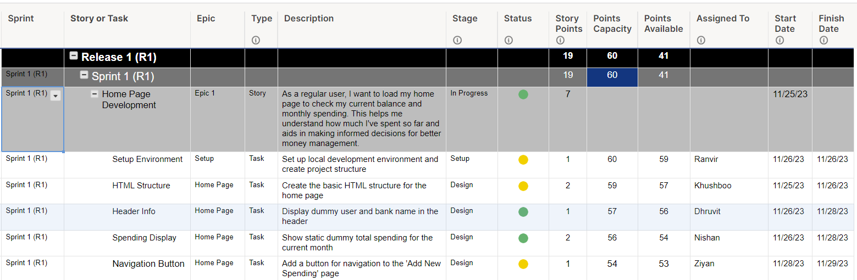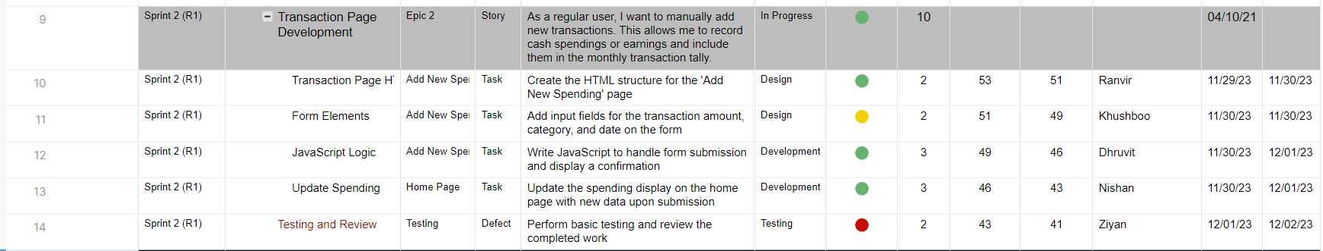

Spring Planner Link: [Click here](https://app.smartsheet.com/sheets/4gVFwrX96Pr7JFMWFW7V5RJPcFcvWrGHJ422CW91?view=grid)

**BurnDown Chart**

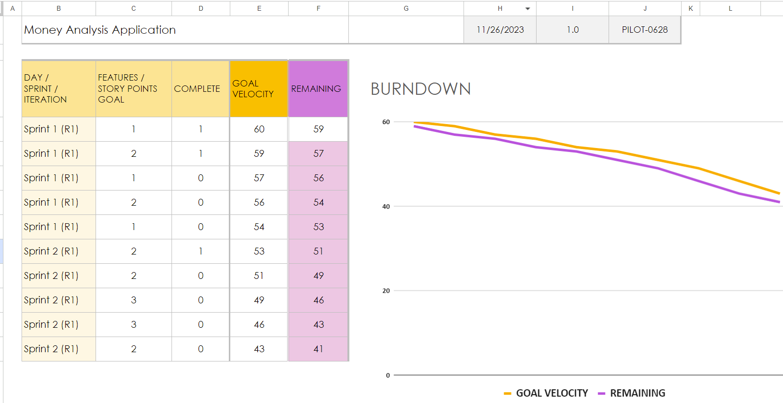Google sheet Link: [Click Here](https://docs.google.com/spreadsheets/d/1GyjThBu2r28U-As8WaouU-Lh-_ofnanWopZGIQMRre4/edit?usp=sharing)

**GitHub:**

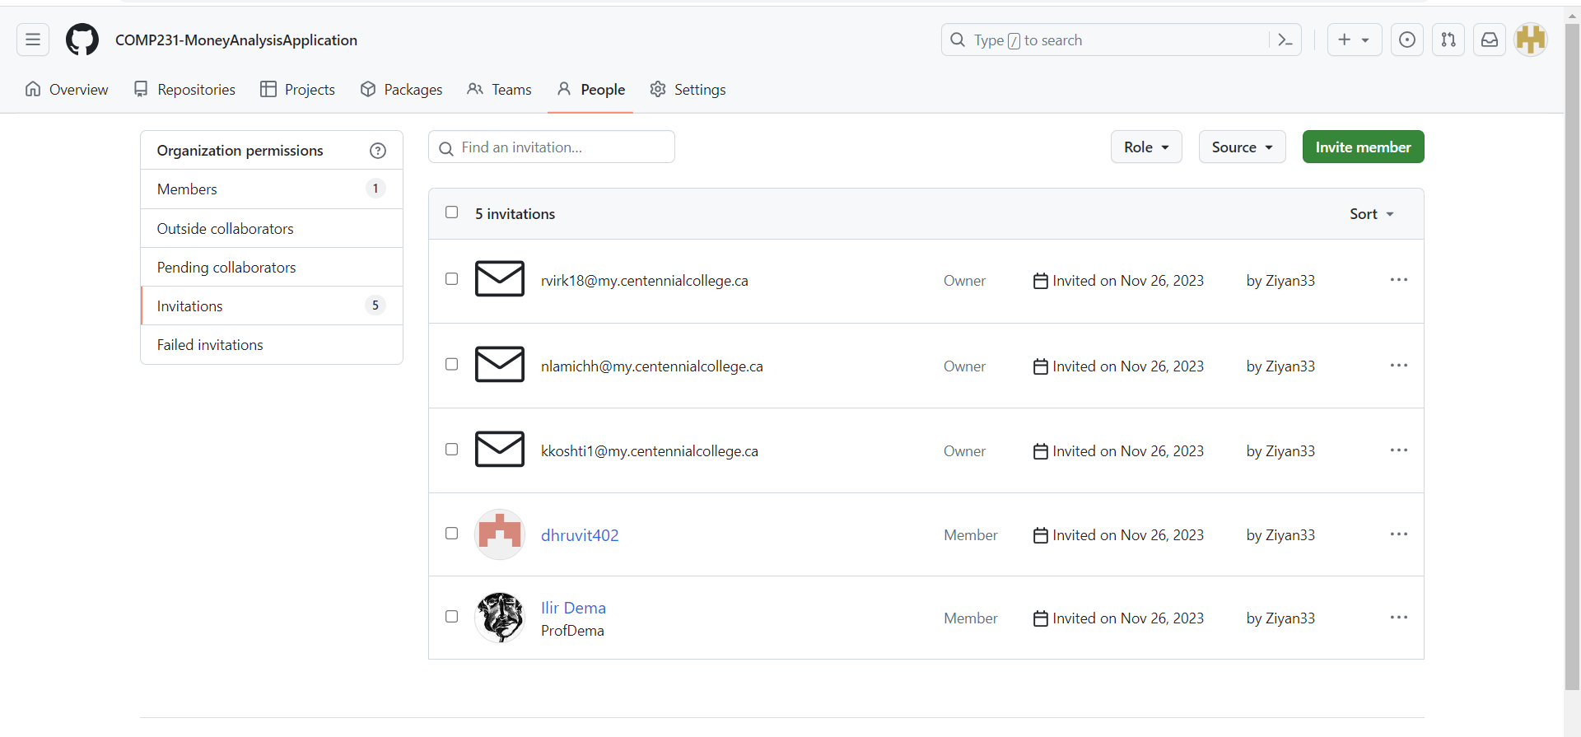

GitHub Link: [Click here](https://github.com/COMP231-MoneyAnalysisApplication)